Term 4
October/November 2018

Hi to our lovely Montessori community

Welcome to a wonderful Term 4, with lots of learning and fun to be had! Santa will be visiting! We hope you all had a good first fortnight back and enjoyed your sun filled long weekend!

Renovation Update

I have shown the teachers through the newly renovated preschool at 99 Grange Rd! The teachers were suitably impressed! :) We are really excited about our move home again! Please be assured that we are still retaining our intimate small numbers of no more than 20 per class, with two spacious classrooms. Your children will be moving back into their old classroom (newly renovated that is!), with the same teachers and the same children. For new poppets who have joined us while we have been at Balmoral, please be rest assured the classroom, deck and large back yard will be enjoyed by our little ones. For clarification, the second classroom will be inhabited by our Smart Start Montessori class/family from Ellerton Rd preschool. It is exactly the same size, with a mixed age group (like ours), with no more than 20 children. Both classrooms lead onto a large covered deck. This deck serves two important functions. Firstly, it extends our classroom space and secondly, allows the children to work or play outside even if it is raining or even hailing. Our building team are going as fast as they can to finish for a council inspection and then we will seek Ministry approval. We aim to have an “opening” in late January before Term 1 begins (29th January 18) so you and our little ones can all have a chance to acquaint yourselves with your new environment. At present, our backyard is all soil, (which we had to top up to meet the deck and stairs) so once our second sandpit is built then grass will be grown and nurtured over the summer break! I have attached a photo of one of our classrooms and the children’s bathroom as a sneak preview.

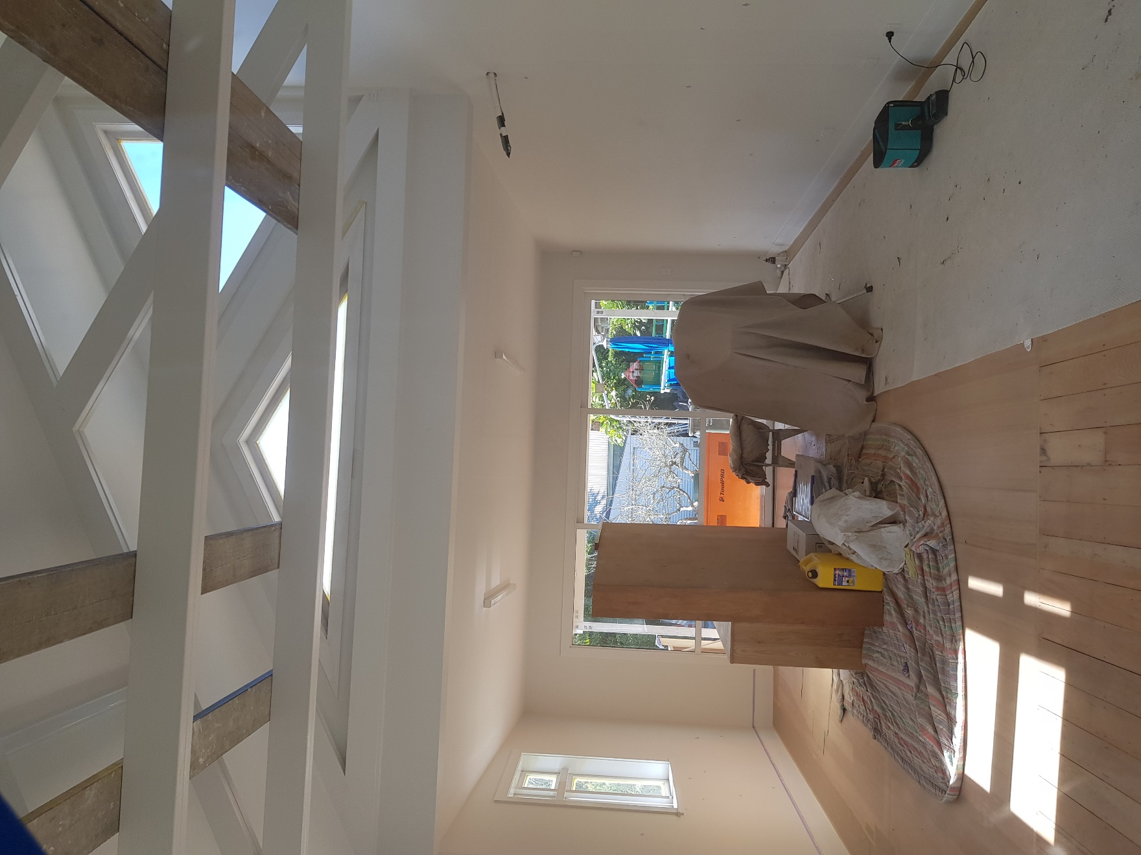

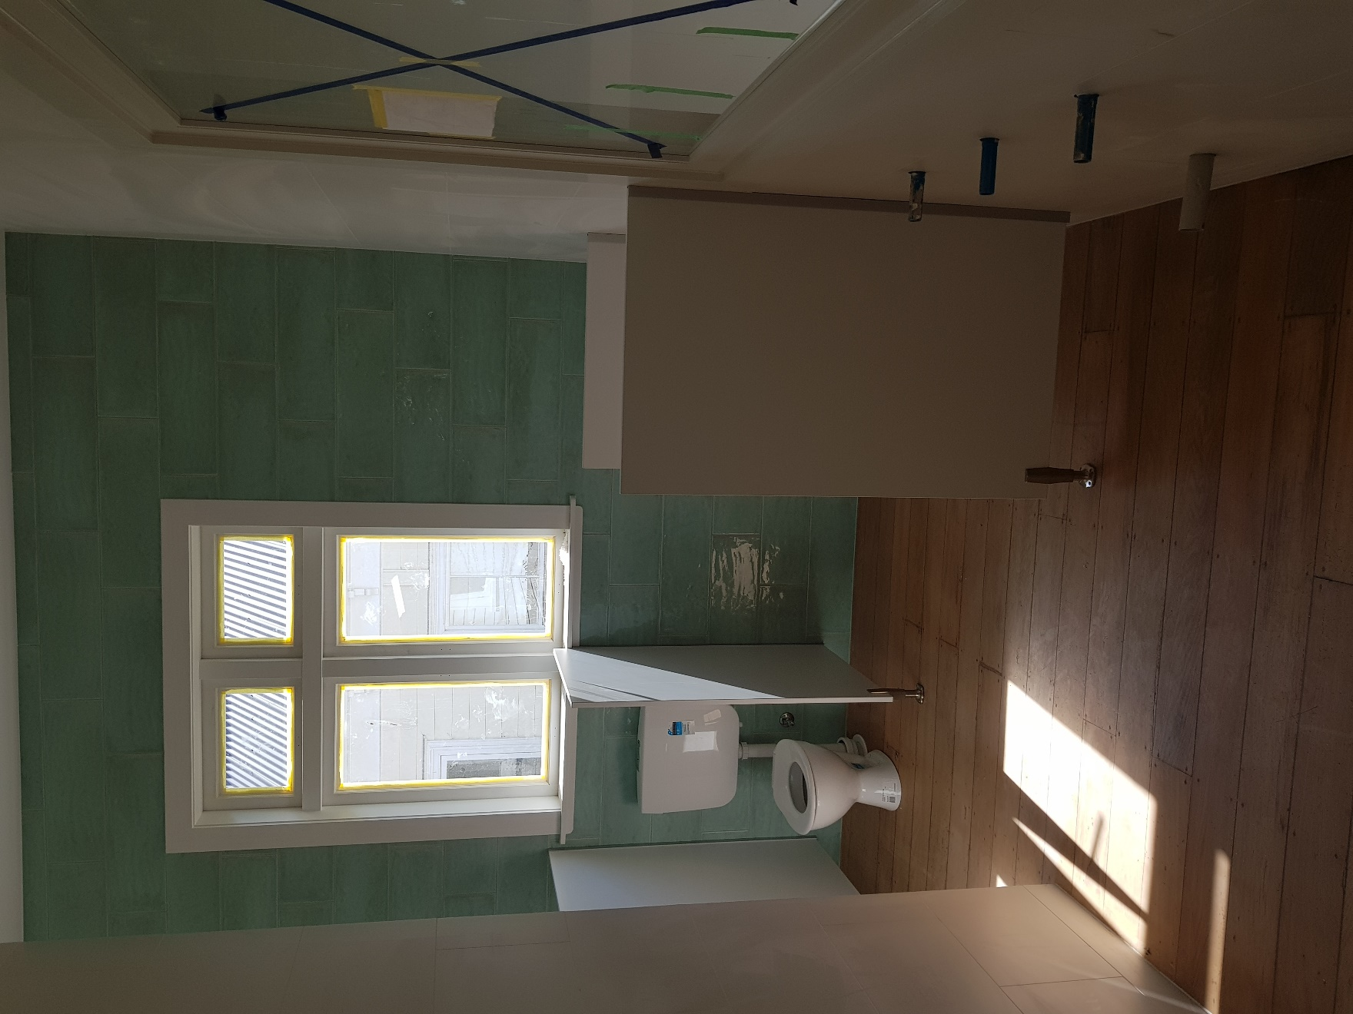

A big welcome- Haeri Mae to:

To three precious siblings! Firstly, Annabel and Conrad! It is so lovely to welcome you and your beautiful Smart Start families back and catch up on all the news of your big eldest siblings! The third sibling, the very sweet sister of Regan, whom is taking very good care of his sister in the classroom!

Last but not least! Haeri Mae to: Ms Summer!

Summer (Yanyan) Li

Tena Koutou, greetings to you all. My name is Yanyan Li (李燕燕). I am from China and have been living in New Zealand for 7 years. Summer is my favorite season, therefore, when my Chinese name always got mispronounced a few years ago, I named myself Summer.

Before I came to New Zealand, I lived in our capital city Peking (北京) for five years. I worked as a student consultant in AIDI International School, where I realised I wanted to be a teacher. I really enjoyed sharing my knowledge with parents and students, and I strongly recognised the power of education. This experience inspired me to study in New Zealand and become a teacher.

I graduated from Auckland University of Technology with a Bachelors Degree in Montessori Early Childhood Teaching in July 2017. Now with one year working experience in the Montessori field, I see that the Montessori approach supports a child’s independence. It is fundamental to their development. Being independent is beneficial not only to a child’s childhood but also to his/her adulthood. When someone is independent, they can adapt to society and explore the world without relying on others. Also, the Montessori method provides children with freedom of choice. I believe this is of importance to a child because when he/she has a choice to choose what he/she really likes, he/she tends to be more focused and motivated.

I am very glad to work at Smart Start Montessori Preschool and look forward to getting to know each family. Thank you for your warm welcome.
Sunhats and Sunscreen!

With the warm weather approaching….
In accordance with our sun care policy, please make sure your children have sunscreen on before they come to school (we will make sure they are topped up as necessary) and that they bring named sunhats.

Happy Diwali

Happy Diwali or Deepavali (row of lamps) for the 7th November! Diwali signifies the triumph of light over darkness, good over evil and the renewal of life. The children will celebrate Diwali by coloring Rangoli patterns and cooking pakoras.

Important Dates to put in your diaries-Notices to follow

Christmas Sing-A-Long – Friday 7th December 2018

Parent Teacher Interviews- 27th November 2018

Grandparents Week- 10th December-14th December 2018

Fish and Chip (Takeaways) Night- 23rd November 4.30pm-6.30pm at Centennial Park

Xmas Holiday Program- 17th-21st December 2018

Summer Holiday Program- 14th-25th January 2019

Reading Bags

Just a kind reminder to please bring your child’s reading bags on the day your child has his or her reading. In the past, we have been giving children reading materials even though they don’t bring their reading bags on their given day. This has resulted in us loosing some of the reading material. The lovely teachers would really appreciate not having to chase up our precious reading materials.
On this topic, we will be reviewing and updating our reading program over the next coming terms.

Montessori Equipment

I’m sure it is very easy to look at the shelves of the Montessori classroom and think, “Oh, how ordered but what on earth can our children do with all these?” With luck, the scientific genius of the Montessori approach will become apparent and we shall all be a little less mystified by it all!
We shall start with an exploration of the Sensorial materials.
Sensorial Materials aid the child in the refinement of their senses. Each of the sensorial materials isolates one quality such a colour, weight, shape, texture, size, sound, smell, etc. The children become involved in pairing, grading and sequencing these materials. They will use cubes, prisms and long rods to build and help develop his powers of discrimination. Precise language such as loud/soft, long/short, rough/smooth, circle, square, cube and so on is then attached to these sensorial experiences to make the world even more meaningful to the child.
Many of the sensorial exercises are also an important preparation for later learning. When the children grasp the knobs of the cylinder blocks, they do so using the same fingers for holding a pencil so preparing his hand for success at writing. When the child works with the pink tower they carry each cube to the mat making the journey ten times. Where possible the sensorial materials contain sets of ten objects giving them indirect exposure to the basis of the decimal system.
Knobbed Cylinders
The knobbed cylinders allow the children to experience variations in size: small and tall, thick and thin, and combinations of these. The little ones tend to hold the knobs using the same three fingers that are used in our pencil grip. Many Montessori materials have an in-built control of error (for others it is external) – a feedback mechanism for the child to enable them to self-correct without adult intervention. With the knobbed cylinders this control comes where the child is unable to replace a cylinder in the ‘wrong’ hole.
Maria Montessori wrote of the knobbed cylinders that “the aim is not an external one, that is to say, it is not the object that the child should learn how to place the cylinders, and that they should know how to perform an exercise. The aim is an inner one, namely, that the child train themselves to observe; that they be led to make comparisons between objects, to form judgments, to reason, to decide; and it is in the indefinite repetition of this exercise of attention and of intelligence that a real development ensues".

Red Rods
The red rods are a popular and often used sensorial material which provide an understanding of size, develop muscular and visual perception of dimension which leads to observation and knowledge. Small motor skills are developed through their manipulation and children are indirectly exposed to and prepared for mathematical concepts such as sequence and order, the decimal system (walking back and forward from the shelf 10 times as they set up) and finally adding.
Children will initially engage with this material ordering the rods from shortest to longest. Visual discernment is at play here as well as muscular perception as the longer the rod the heavier it gets. The language used is also important as children begin to use comparative and superlative descriptions for the objects in their hands. There are numerous extension activities that the children may choose to engage in with the Red Rods once the base concepts are down pat. A popular creation is the Red Rod maze as the kiddos take the shortest to the longest rod and arrange them sequentially and perpendicularly to the last.
Colour Tablets
Montessori coloured tablets sharpen visual acuity. Children begin to understand the colour spectrum with these wonderful lessons. Colour discrimination helps with later learning, such as using logic, classification of similar and different objects, groupings and patterns of color in nature. This exercise helps develop visual language skills. These visual skills are used in reading and math skills. There are three boxes of colour tablets. Box 1 contains 3 pairs of the primary colours: red, blue, yellow. Box 2 contains pairs of primary and secondary colours as well as black and white. Box 3 contains nine sets of graduated colours.

Newsletter – Email
If any families, particularly new families wish to receive the newsletter by email, please forward your email address to:info@smartstart.school.nz or contact Rebecca Ph 623-0097

Children’s News

Just a gentle reminder that when your child brings news, please make sure the item is something that is special to them. For example Birthday photos, holidays and trip photos, special events and favourite books, not McDonald toys etc.

Recycling Paper
We appreciate if anyone is aware of any company that is downsizing or has excess recycle paper to give away for our children to draw or paint on. Eg. Calanders, computer print outs, spare card etc.

Thank you!
Thank you to Zoey’s family, for kindly donating wall paper rolls for the children last term.

20 Hours ECE
Just a reminder that if your child turns three during the term and you wish to take advantage of the 20 hours ECE subsidy, please speak to Rebecca in the office. Also if you make any changes to your child’s preschool hours this needs to be changed on the 20 Hours Free Attestation form. Please contact Rebecca in the office to arrange this.

Allergies
Just a reminder about the danger of allergies for our little ones. We have children at both schools with severe allergies. We ask that the following be excluded from lunch boxes; Whole egg e.g. egg sandwiches. Any nuts and any food containing nuts. Some packaging states that the food within may contain traces of nuts. As long as the nuts aren’t part of the ingredients, this is alright to include this in your child’s lunchbox. Seeds are fine as well. We kindly thank all parents for their consideration in this matter. For birthdays and graduations, if you want to provide something for the children to share, fruit platters or fruit kebabs are an excellent healthy option, and this means that no child is left out.

Leaving Policy
Please note 6 weeks notice is required to withdraw your child from preschool. This notice must be received in writing. Please note that this notice needs to be given during term time i.e. not during the
holidays. We understand that circumstances can change over the summer holidays, however due to many of our families and those on the waiting list being away, we are unable to contact them and organize spaces to be filled.

Birth Certificates/Immunisation Documentation
The Ministry of Education requires Smart Start to have a copy of either children’s birth certificates or passports, and your child’s immunization record. If you have not provided these can you please drop these to the teachers or to Rebecca in the office. If you need us to make a copy, please bring in the original and we will do this for you.
Portfolios

Please take some time to catch up on your child’s portfolio, and add your voice, but remember to bring it back please.
Website News
The Smart Start Montessori website is a great way to keep up
dated with what is going on in the preschools as well as giving information about upcoming events. We are in the process of upgrading it, and posting our policies and procedure onto it so you can view them at leisure if you wish to. www.smartstart.school.nz
Term Dates 2017
Term 4 Finishes on
Friday 14th December 2018
Term 1 Monday 29th January
To Friday 13th April 2018

