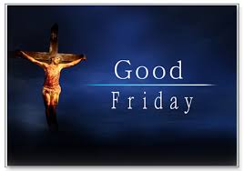
Easter Triduum Reflections
By Fr Marcus Francis
- The Triduum
These three days from Holy Thursday the Easter Vigil are the most important days of the Catholic calendar. In them the entire Christian mystery is experienced in a concentrated and powerful way. Our liturgical journey with Jesus from Galilee to Jerusalem reaches its destination and the significance of this reverberates all through Eastertide until we arrive at Pentecost. I cannot overstate how important these days are to our life as Catholics. I encourage all parishioners to attend the ceremonies to deepen their faith and understand better the mysteries we celebrate on Sundays. The Palm Sunday and Chrism Mass celebrations are a fitting lead up to the great feasts.
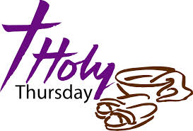
- Holy Thursday
Instead of the Institution Narrative at the Last Supper John’s Gospel relates the “washing of the feet” in the context of the Passover meal. Explaining himself Jesus say: “So if I, your Lord and Teacher, have washed your feet, you also ought to wash one another’s feet. For I have set you an example, that you also should do as I have done to you.” (Jn 13: 14-15) The gift of the Eucharist, “Do this in remembrance of me” (1 Cor 11: 24) is interpreted in the light of this act of service and self-giving. This is to be imitated by the disciples. St Paul, elsewhere, indicates that we cannot truly and sincerely participate in the Lord’s Supper if we do not, at the same time, treat each other with the respect and dignity that each deserves: “For all who eat and drink without discerning the body [meaning the Church as the Body of Christ], eat and drink judgment against themselves… So then my brothers and sisters, when you come together to eat, wait for one another. If you are hungry, eat at home, so that when you eat together it will not be for your condemnation.” (1 Cor 11: 29, 33-34) Let us therefore be mindful of how we behave in and around our attendance at Mass and our behaviour towards others as fellow disciples and members of the Lord’s body.
- Good Friday
This commemoration of the Lord’s Passion draws us more deeply into the implications of Jesus’ complete devotion to the will of the Father. His suffering is indeed horrific but that is not the point. Jesus was open to whatever was required from him so that the love of the Father for humanity would be vindicated: “Father, if you are willing, remove this cup from me; yet not my will but yours be done.” (Lk 22: 42) It is through his obedience that Jesus brings about salvation however, in his case, this was learnt through suffering: “Although he was a Son, he learned obedience through what he suffered; and having been made perfect, he became the source of eternal salvation for all who obey him.” (Heb 4: 8-9) St Paul saw the obedience of Christ as repairing the relationship with God ruptured by the disobedience of Adam: “For if many died through one man’s trespass, much more surely have the grace of God and the free gift of in the grace of one man, Jesus Christ abounded for the many.” (Rom 5: 15) The result of the Cross is that Christ’s obedience frees us from slavery to sin: “But thanks be to God that you, having once been slaves of sin, have become obedient to the form of teaching to which you were entrusted, and that you, having been set free from sin, have become slaves of righteousness.” (Rom 6: 17-18) Do I live my life as a slave of righteousness or do I hanker after the “flesh pots of Egypt” (see Ex 16: 3): selfishness, grudges, sexual immorality, greed, spite and self-righteousness?
At the conclusion of the liturgy we depart in silence reflecting on what was done. Our solicitude for fellow Christians in the Holy Land suffering under hardship and persecution is manifested in our giving to the collection for the Holy Places Like St Paul taking up the collection for the Christians of Jerusalem we are mindful of our communion throughout the world: “They asked only one thing, that we remember the poor, which was actually what I was eager to do.” (Gal 2: 10)

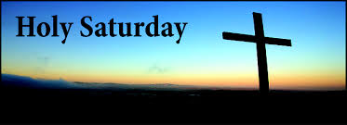
- Holy Saturday

This is a day of waiting. No sacraments are celebrated on this day unless in danger of death. We rest with Christ in the darkness of the tomb: “O LORD, God of my salvation, when, at night, I cry out in your presence, let my prayer come before you; incline your ear to my cry. For my soul is full of troubles, and my life draws near to Sheol. I am counted among those who go down to the Pit; I am like those who have no help, like those forsaken among the dead, like the slain that lie in the grave, like those you remember no more, for they are cut off from your hand. You have put me in the depths of the Pit, in the regions dark and deep. Your wrath lies heavy upon me, and you overwhelm me with all your waves.” (Ps 88: 1-7)
This prompts the questions: do I avoid suffering in my life? What is my attitude to the sufferings in my past life? Have I brought them to the Lord to ask for healing? Am I in denial of the harm my sins have caused to myself and to others as well as offending the love of God for me?

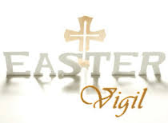

- Easter Vigil

The Easter Vigil is a wonderful celebration of light, joy and faith. The ceremony of light powerfully communicates what Christ’s resurrection means for us. We hear of the history of salvation and the glory of the Resurrection. When adults are baptised, confirmed and receive Eucharist, or are sprinkled with holy water, the whole community is built up and reminded of their own life of faith and their baptismal dignity: “But you are a chosen race, a royal priesthood, a holy nation, God’s own people, in order that you may proclaim the might acts of him who called you out of darkness into his marvellous light.
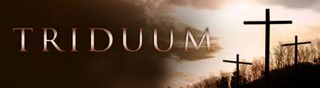
Once you were not a people, but now you are God’s people; once you had not received mercy, but now you have received mercy.” (1 Pet 2: 9-10)

