MEDIA RELEASE
‘THE SKIPPER’S DIARY’
The story of ‘The Forty-Niners’
The New Zealand Cricket Team Tour of England in 1949

Compiled by Sir Richard Hadlee

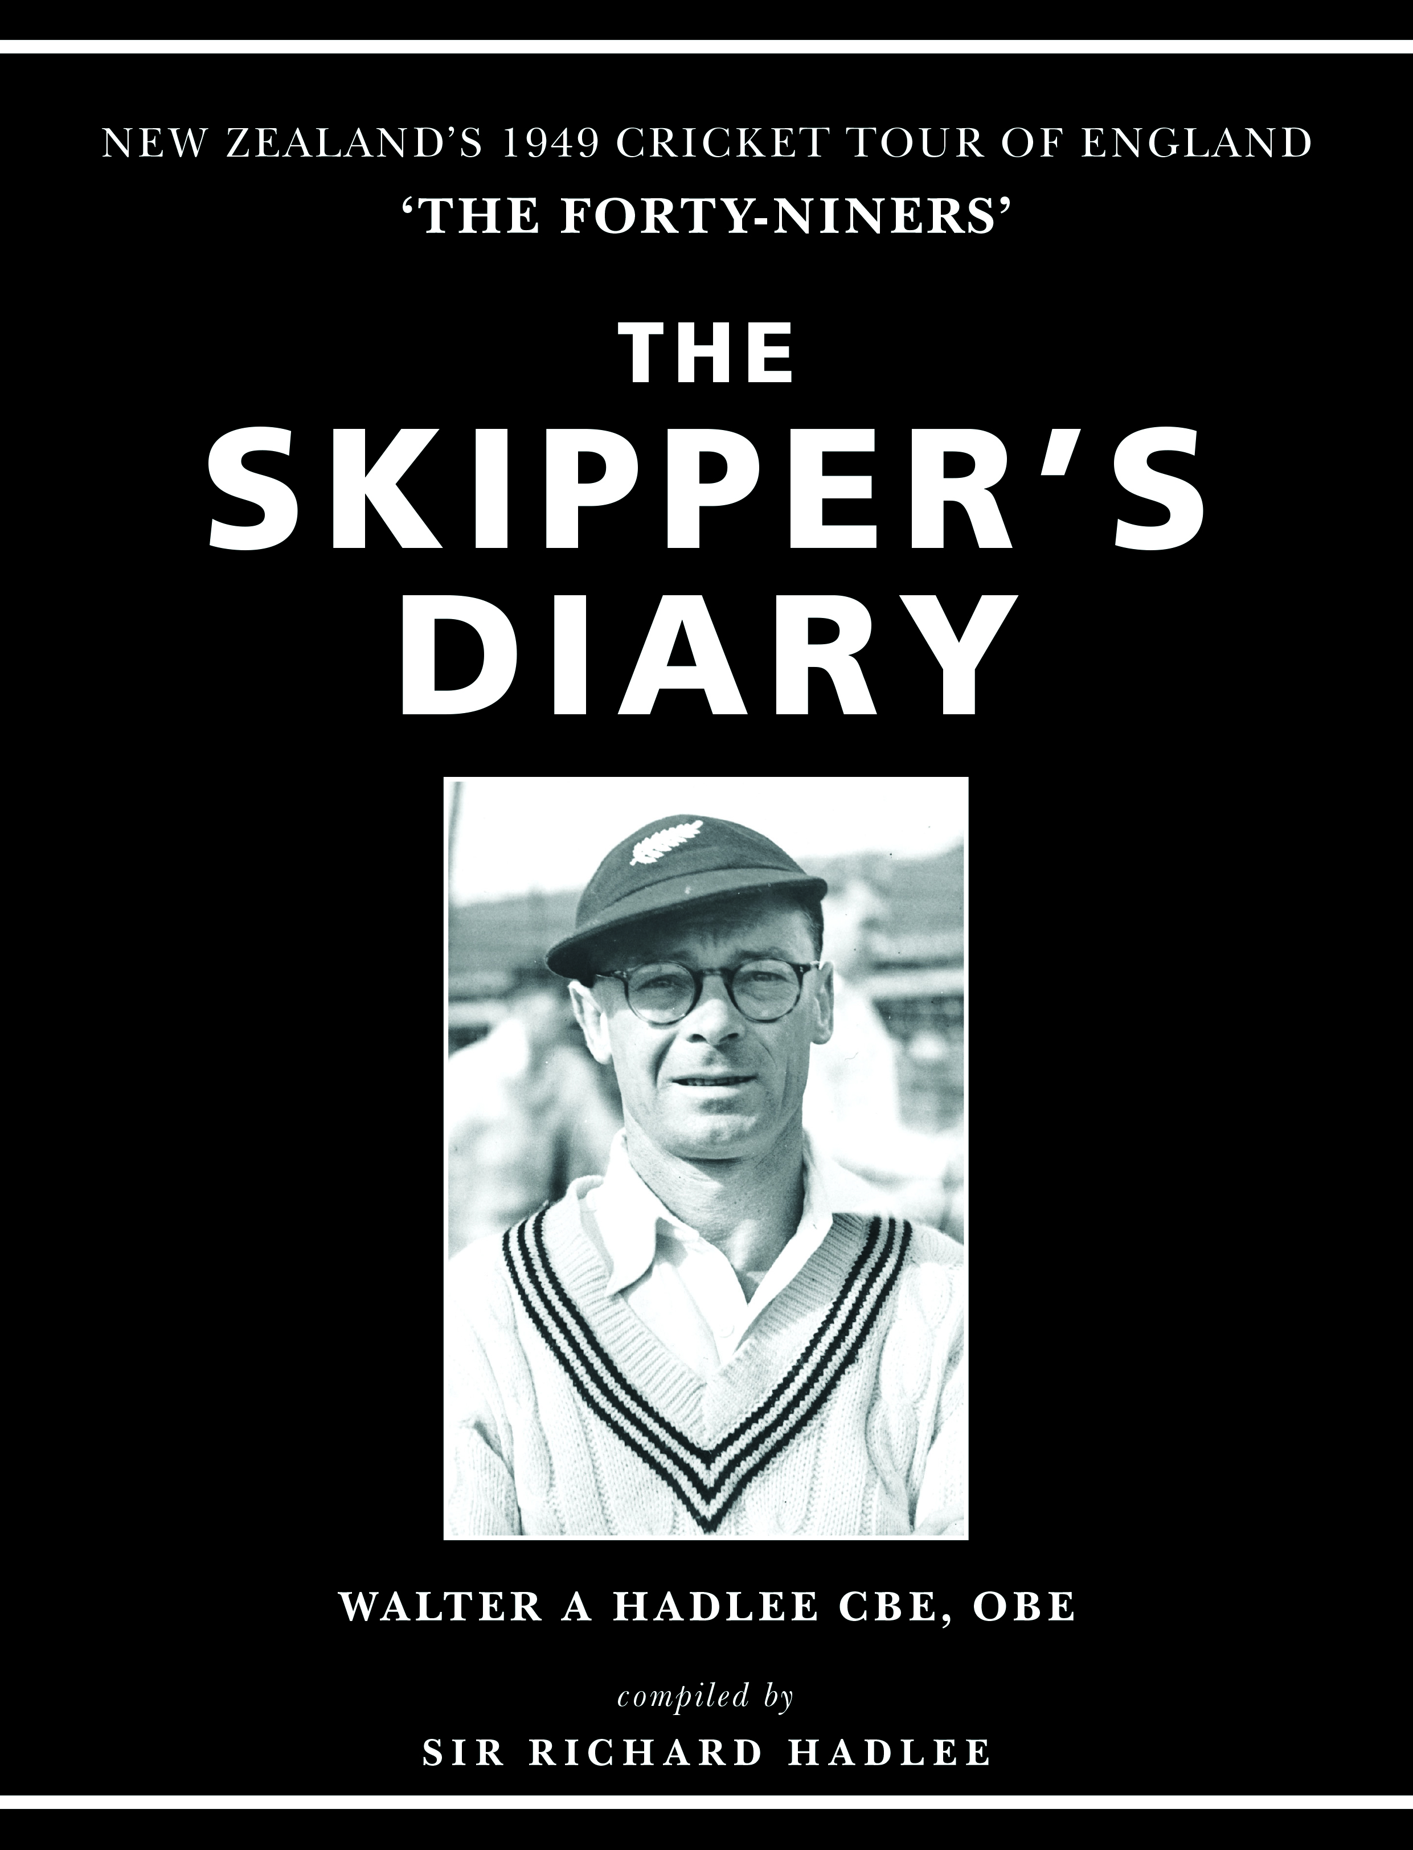
Sir Richard Hadlee’s father, Walter, captained the New Zealand Cricket Team on the 1949 Tour of England. This was the New Zealand team that prompted the rest of the cricketing world to sit up and take notice; enjoying great success, and promoting several players to world-class status.

A campaign that began with a five-week-long sea voyage and lasted a total of eight months, it was played out in war-torn Britain at a time when rationing was still in effect and buildings still lay in ruins, and is brought to life once more in this compelling story, based on the meticulous day-by-day diary entries Walter maintained throughout the trip.

The tour synopsis? It makes for compelling reading. Walter’s side played 32 first-class games, winning 13, drawing 18 and losing just once. Eight of the touring party – Martin Donnelly, Bert Sutcliffe, Merv Wallace, Verdun Scott, Walter, John Reid, Geoff Rabone and Brun Smith, exceeded 1000 runs in first-class matches, at that stage a record for touring teams in England.

Sutcliffe’s aggregate of 2627 was second only to Don Bradman’s 1930 record of 2960. On 26 occasions, New Zealand scored more than 300 in an innings; in ten of those, they exceeded 400.

Since 2014, Sir Richard has worked on developing his father’s journal into a publishable format, embracing the many considered and insightful observations detailed by the man best remembered as the grandfather of New Zealand cricket.

The Skipper’s Diary brings to life again, not just the rich tapestry of post-war cricket in England, but also the adventure and experiences of a journey that included a match in occupied Germany, and a 36-day return voyage - taking the squad through the Panama Canal, into the Pacific Ocean and home via Pitcairn Island.

In The Skipper’s Diary, read about Walter’s thoughts on team selection, from the controversy at home over the omission of Otago’s George Mills, to the early tour concerns over the form of Bert Sutcliffe, and the decision to replace the well-performed Brun Smith with youngster John Reid for the third Test at Old Trafford.

Enjoy Walter’s accounts of meeting with royalty, the speeches he wrote for various VIP functions, and his post-tour reflections on each of the squad members. A man of detail, Walter also offers a sample of costs and expenditure of the time, and reveals the tour contract – signed by all team members before departure.

The contents of the book includes:

- Foreword written by Barry, Martin, Dayle, Richard and Christopher Hadlee
- Introduction to set the scene written by Richard Hadlee.
- The Prologue written by New Zealand cricket historian Don Neely.
- A message from David White the CEO of NZC.
- A message from H.R.H. The Duke of Edinburgh, Prince Philip KG. KT. The Duke was the President of the MCC in 1949 and met the team on four occasions during the tour.
- The Tour Itinerary.
- The Tour Contract signed by the players in 1949.
- The Tour Manager’s Report sent to the NZCC written by Jack Phillipps.
- Player Reflections looking back on the tour.
- The Final Analysis – player statistics and performances complied by Richard Hadlee.
- Match scorecards and summaries.
- Extras – cricket stories and asides.
- What happened to ‘The Forty-Niners’ after the tour?
- Over 150 photographs.

DVD

Included with the book is a complimentary two hour DVD documentary of the tour called ‘The Forty-Niners’, and introduced by Sir Richard Hadlee. The documentary includes reflective player interviews from Walter (also reading from his own diary), Martin Donnelly, John Reid, Merv Wallace, Johnny Hayes, Bert Sutcliffe, and comments from Don Neely. The current Blackcaps coach, Mike Hesson, and captain, Kane Williamson also share their views on ‘The Forty-Niners’. There is black and white archive film footage of the tour and a selection of tour photographs and asides.

119 Limited Edition leather bound books

A special, leather-bound limited edition of the book has been produced. The number 119 is significant as it was Walter’s highest first-class score on tour. The book is beautifully presented, complete with a replica mini cricket bat with signatures of the team, a 1949 Test Match scorecard, Tour Progamme, Postcard, and DVD documentary. A special page is signed by John Reid (the only surviving member of team); the Hadlee brothers, Don Neely, David White and Sir Ron Brierley.

Three charities are being supported in the form of a donation from proceeds of the book sales. The beneficiaries are the New Zealand Cricket Museum (Patron: Sir Richard Hadlee); The Cricket Live Foundation where underprivileged street kids in Sri Lanka and India learn life skills through cricket to give them a better future (Patron: Sir Richard Hadlee); and the NZCPA (New Zealand Cricket Players’ Association) Cricketers’ Trust, supporting cricketers who are in need.

Walter’s Diary is a historical document. It is part of a legacy that will now be preserved, and the players and their exploits remembered forever. For Sir Richard, bringing to life his father’s detailed recollections of the 1949 tour has been both a poignant and exhilarating experience.

A series of promotional book launch events around the country will be hosted by Major and District Cricket Associations from 19th September through October and November.

This 514-page book/DVD is not available in retail shops. To purchase a copy, go online from September 26th 2017 www.theskippersdiary1949.com

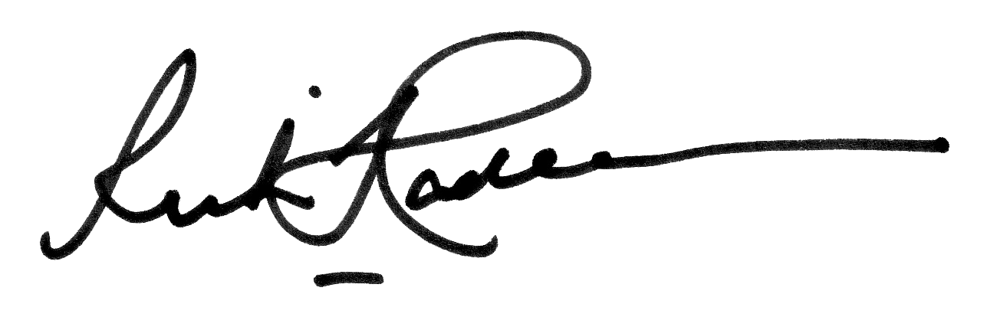
For more information or interviews contact Sir Richard Hadlee
Phone: 021 340436
Email: hadleerj@clear.net.nz

