

21 February 2017

Dear Parents/Caregivers

On Thursday 23rd March we will be holding Parent Teacher Interviews from 2.15pm to 5.55pm.

Each interview is five minutes with your child’s subject teachers. **The school has activated a web site that will enable you to choose an appointment time on this day.** We would encourage parents to use this process. Please see the enclosed instructions on how to access the web site and activate the booking. If you do not have access to a computer please ask your child to bring the enclosed interview time sheet to their teachers who will make an appointment for you. Kindly indicate on this sheet your preferred appointment times. Your child will bring the appointment sheet back home once this has been confirmed. Time slots will be limited. **Please be aware these interviews are just a snapshot of your child’s progress to date and an opportunity to meet the teachers. Please consult your child’s timetable when booking teachers. Refer to the back of this sheet; where you will find a key for the Teacher Codes that are on your student’s timetable.** More in-depth interviews will be occurring on Family Days in Term 2.**The website will CLOSE for appointments on Wednesday 22nd March**

Web Address: <http://www.schoolinterviews.co.nz>

Password/Code: **qbmns**

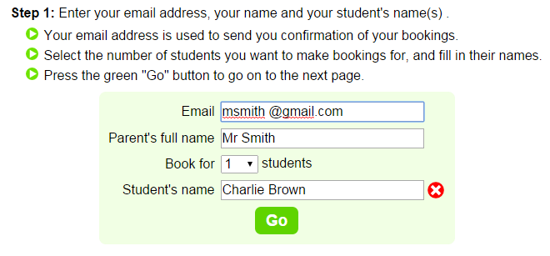

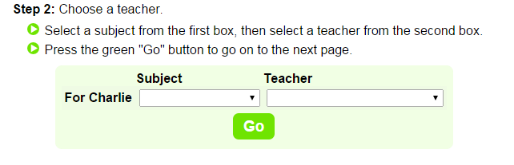

**Step 3:** Select your interview time. You will need to repeat this process for each interview you require. We suggest that you prioritise who you would like to see.

|  |  |  |  |
| --- | --- | --- | --- |
| **Surname** | **First** | **Title** | **Code** |
| Bullock | Martin | Mr | MB |
| Manuel | Kamaka | Mr | KM |
| Dayal | Lalina | Mrs | LD |
| Goldsworthy | Emma-Jane | Miss | EG |
| Kendrick | Gaylene | Ms | GK |
| Penn-Reina | Lida | Sra | LP |
| Bullock | Anne-Marie | Ms | AB |
| Bullock | Tasha | Mrs | TB |
| Davis | Beryl | Mrs | BD |
| Hepburn | Hayden | Mr | HH |
| Jenkins | Toni | Dr | TJ |
| Perry | Marco | Mr | MP |
| Sinclair | Adam | Mr | AS |
| Duggan | Erica | Mrs | ED |
| England | Christine | Ms | CE |
| Ansley | Rose | Mrs | ROAN |
| Benefield | Debra | Mrs | HD |
| Daignault | Darryl | Mr | DD |
| Davies | Caitriona | Mrs | CD |
| Duxfield | Ginni-Rae | Mrs | GD |
| Foster | Eleanor | Ms | EF |
| Fraser | Anna | Ms | AF |
| Hart | Sophie | Mrs | SH |
| Hayes | Lance | Mr | LH |
| Jacques | Kerrigan | Mr | KJ |
| Monaghan | Patrick | Mr | PM |
| O'Hara | Kathleen | Ms | KO |
| Rauhina | Vaan | Mr | VR |
| Robertson | Kaye | Miss | KR |
| Sleyer | Mary Anne | Mrs | MAS |
| Syme | Ivan | Mr | IS |

**On the day of the interviews, please avoid the Office area due to the demolition work. Please enter the College via the Chapel Walkway. Senior students will be available to direct you to the Gymnasium or kindly follow the signposts/arrows.**

**Teacher Lists and Codes**



February 2017

Dear Parents/Caregivers

**PARENT TEACHER INTERVIEWS THURSDAY 23RD MARCH 2017**

**This form is to be used ONLY if you are unable to book online**

NAME OF STUDENT:

|  |  |  |  |
| --- | --- | --- | --- |
| **SUBJECT** | **TEACHER** | **PREFERRED TIME** | **Time Confirmed by Teacher** |
| 1. Religious Education |  |  |  |
| 2. |  |  |  |
| 3. |  |  |  |
| 4. |  |  |  |
| 5. |  |  |  |
| 6. |  |  |  |
| 7. |  |  |  |
| 8. |  |  |  |
| 9. |  |  |  |
| 10. |  |  |  |
| 11. |  |  |  |

Teachers will schedule 5 minutes for each interview. Should you require more than 5 minutes with a particular staff member feel free to arrange an appointment time at another time during the week. Please make your appointments 10 minutes apart to allow time to move. If your son/daughter is also attending they must be in school uniform. Interviews start from 2.15pm and the final interview time is 5.55pm.

**These times will only be reserved for you if your daughter/son actually sees the teacher concerned so that they can record the time(s). Please indicate above your preferred time and staff will try to accommodate you as appointments permit.**

Students will be released at 1.40pm. School will be closed and buses will be available at normal bus times.

Yours sincerely

L Penn-Reina

Senior Manager