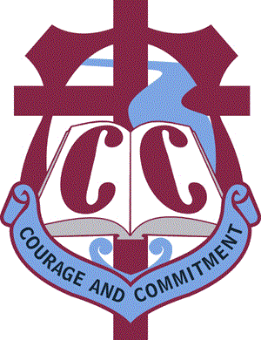
Mufti Day Tuesday 25th October 2016

Dear Parents/Caregivers

On Tuesday 25th October we are going to run a Mufti Day for both students and staff to raise some money for Leuka Coffey’s family.

Leuka is the young man from our College who broke his neck in an accident in Christchurch over the school holidays. He is currently in Burwood Spinal Unit (Christchurch) where he is on a breathing machine and has little movement to speak of.

It is a very sad and challenging situation and it is likely he will remain at Burwood Hospital for three to six months. As a result, it is particularly difficult for his mother and family as she has had to leave Whanganui to be at her son’s side. We would like to support the family by raising some money to help with her living costs etc. We would ask that students bring a minimum gold coin donation for the Mufti Day but we would also be very happy to pass on any donations to the family.

We continue to pray for Leuka as he remains very much in our thoughts.

K B Shore
Principal

Mufti Day Tuesday 25th October 2016

Dear Parents/Caregivers

On Tuesday 25th October we are going to run a Mufti Day for both students and staff to raise some money for Leuka Coffey’s family.

Leuka is the young man from our College who broke his neck in an accident in Christchurch over the school holidays. He is currently in Burwood Spinal Unit (Christchurch) where he is on a breathing machine and has little movement to speak of.

It is a very sad and challenging situation and it is likely he will remain at Burwood Hospital for three to six months. As a result, it is particularly difficult for his mother and family as she has had to leave Whanganui to be at her son’s side. We would like to support the family by raising some money to help with her living costs etc. We would ask that students bring a minimum gold coin donation for the Mufti Day but we would also be very happy to pass on any donations to the family.

We continue to pray for Leuka as he remains very much in our thoughts.

K B Shore
Principal

