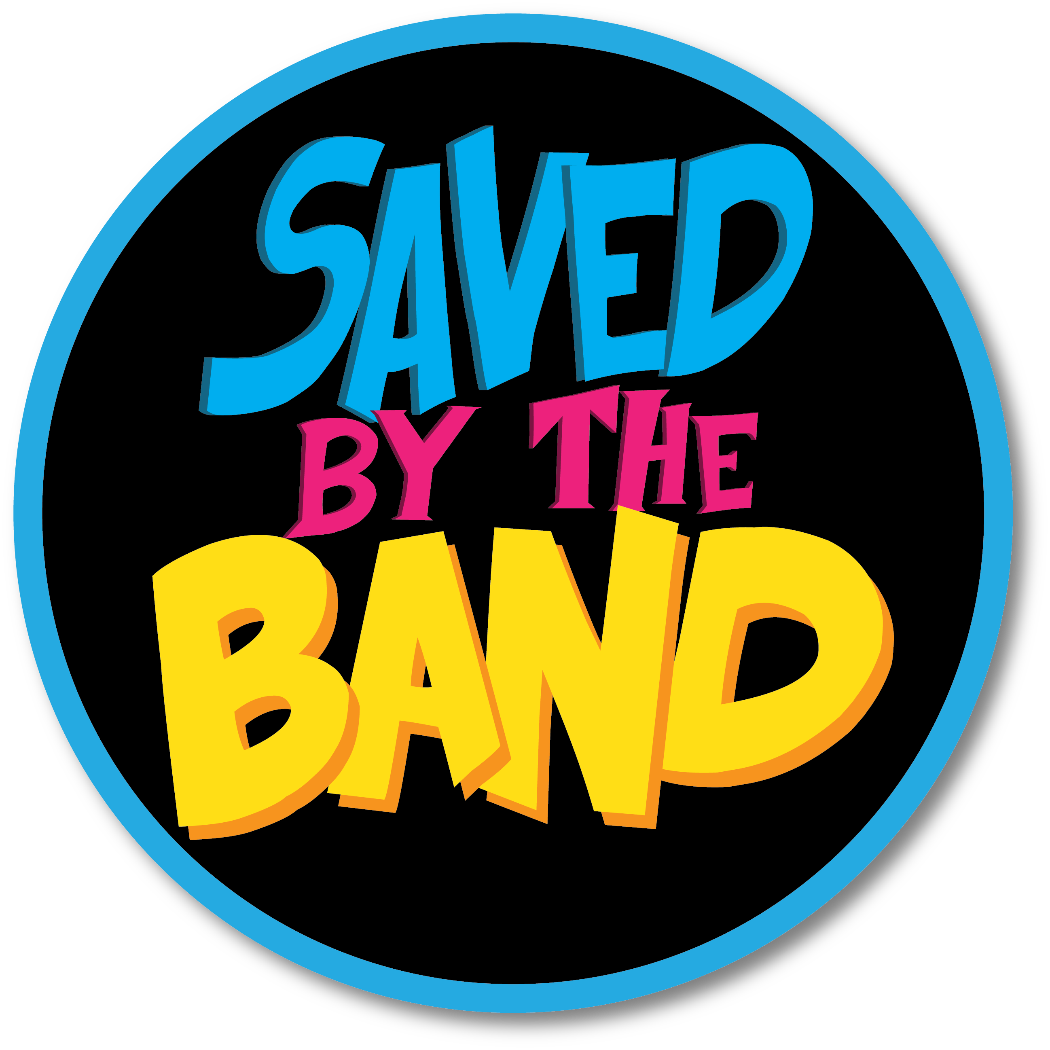

867-5309 (Jenny) - Tommy Tutone
Addicted to Love – Robert Palmer
American Girl - Tom Petty
Are You Gonna Be My Girl – Jet
Are You Gonna Go My Way – Lenny Kravitz
Basket Case - Green Day
Been Caught Stealing – Jane’s Addiction
Blister In The Sun- Violent Femmes
Buddy Holly – Weezer
Bust A Move – Young MC
Centerfold – J. Geils Band
Closing Time- Semisonic
Creep – Radiohead
Dancing in the Dark – Bruce Springsteen
Dancing With Myself - Billy Idol
Don’t Speak – No Doubt
Don’t Stop Believin - Journey
Don’t You (Forget About Me) - Simple Minds
Even Flow – Pearl Jam
Everlong- Foo Fighters
Flagpole Sitta - Harvey Danger
Fight For Your Right – Beastie Boys
Friends In Low Places – Garth Brooks
Give It Away – Red Hot Chili Peppers
Groove Is In The Heart – Deee Lite
Hard To Handle - The Black Crowes
Here In Your Bedroom - Goldfinger
Hit Me With Your Best Shot - Pat Benatar
Highway To Hell - AC/DC
Home Sweet Home – Motley Crue
How Soon Is Now – The Smiths
Hungry Like The Wolf – Duran Duran
Hurts So Good – John Mellencamp
I Believe In A Thing Called Love - The Darkness
I Melt With You – Modern English
I’m Gonna Be (500 Miles) - The Proclaimers
I Need You Tonight - INXS
Inside Out- Eve 6
In The Mean Time- Spacehog
Ironic - Alanis Morissette
It Ain’t Over Til It’s Over – Lenny Kravitz
It’s The End Of The World As We Know It – REM
I Wanna Dance w/ Somebody – Whitney Houston
I Want You To Want Me - Cheap Trick
Jessie’s Girl - Rick Springfield
Just Like Heaven - The Cure
Just What I Needed- The Cars
Kiss – Prince
Laid - James
Last Nite- The Strokes
Let’s Dance – David Bowie
Livin' on a Prayer - Bon Jovi
Lithium- Nirvana

SONG LIST

Longview- Green Day
Loser - Beck
Love Shack – The B-52’s
Lump - The Presidents of the United States of America
Message In A Bottle – The Police
Mr. Brightside - The Killers
Mr. Jones – Counting Crows
My Own Worst Enemy- Lit
My Sharona - The Knack
No Diggity - Blackstreet
No One Knows- Queens of the Stone Age
One Way Or Another - Blondie
Peaches – The Presidents of the United States of America
Possum Kingdom - The Toadies
Pour Some Sugar On Me - Def Leppard
Purple Rain – Prince
P.Y.T. – Michael Jackson
Rebel Yell- Billy Idol
Runnin Down A Dream - Tom Petty
Say It Ain’t So – Weezer
Semi Charmed Life – Third Eye Blind
Sharp Dressed Man – ZZ Top
Should I Stay Or Should I Go – The Clash
Since U Been Gone- Kelly Clarkson
Song 2- Blur
Sugar – Maroon 5
Summer of ‘69 - Bryan Adams
Surrender - Cheap Trick
Stay - Lisa Loeb
Undone (The Sweater Song)- Weezer
Talk Dirty to Me- Poison
Take Me Out- Franz Ferdinand
Teen Angst – Cracker
Tell It To My Heart – Taylor Dayne
The Distance - Cake
The Middle - Jimmy Eat World
Tonight, Tonight- Smashing Pumpkins
Total Eclipse of the Heart – Bonnie Tyler
Under Pressure – Queen/David Bowie
Undone (The Sweater Song) – Weezer
Walking On Sunshine- Katrina & the Waves
Wanted Dead Or Alive- Bon Jovi
We’re Not Gonna Take It - Twisted Sister
What I Like About You – The Romantics
When You Were Young – The Killers
Where Is My Mind? - Pixies
Working For The Weekend – Loverboy
You May Be Right – Billy Joel
Your Love – The Outfield
You Oughta Know- Alanis Morissette
You Shook Me All Night Long - AC/DC

