WHANGANUI CHARITABLE FOUNDATION

INVENTORY OF CHATTELS AT 7 PARK PLACE, WHANGANUI

Board Room

Item Description

1. 14 x swivel chairs

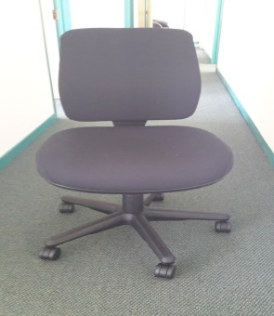

Link to larger image : Swivel chair

2. 4 x mobile tables (800mm x 1800mm)

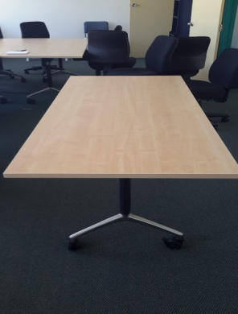

Link to larger image : Mobile table

3. 1 x whiteboard on easel

Link to larger image : Whiteboard on easel

4. 3 x De Longhi Sigura System heaters

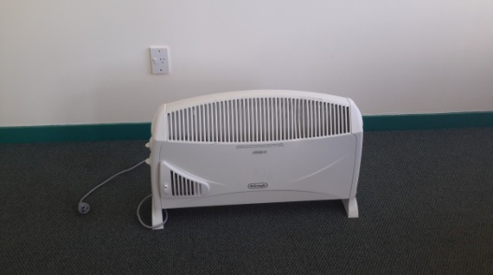

Link to larger image : De Longhi Sigura System heater

5. Blue mobile drawers (6 x 4 drawer, 2 x 3 drawer) (480mm x 680mm)

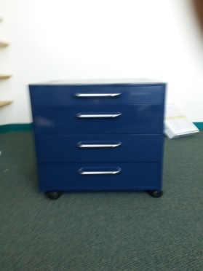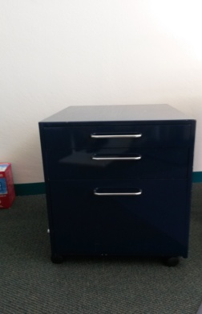
4 drawer unit 3 drawer unit

Larger images not available

6. 1 x blue table (760mm x 1380mm)

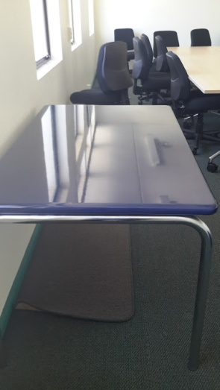

Link to larger image : Blue table

7. 1 x blue 5 shelf book case

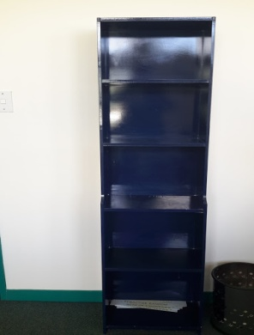

Link to larger image : Blue 5 shelf book case

Lounge Area

8. 2 x blue tables (800mm x 1500mm)

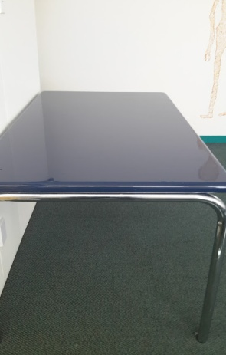

Link to larger image : Blue table

9. 1 x blue coffee table (770mm x 770mm)

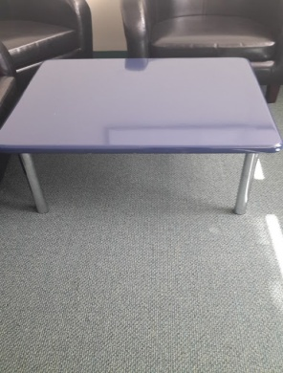

Link to larger image : Blue coffee table

10. 10 x chub lounge chairs

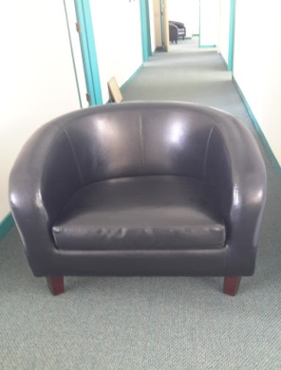

Link to larger image : Chub lounge chair

Kitchen

11. Fisher & Paykel fridge/freezer (Fridge 640mm x 900mm)
(Freezer 640mm x 440mm)
(Depth 640mm)
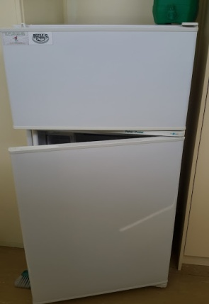

Link to larger image : Fisher & Paykel fridge/freezer

12. Sundry crockery

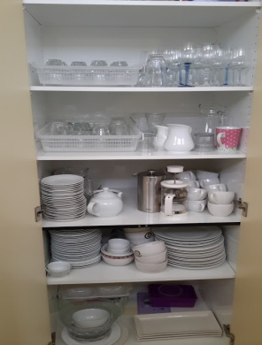

Link to larger image : Sundry crockery 1 Sundry crockery 2

Office 1

13. 4 x metal frame chairs, blue fabric

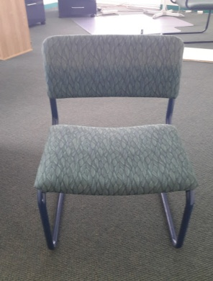

Link to larger image : Metal frame chair, blue fabric

14. 1 x View Sonic Projector

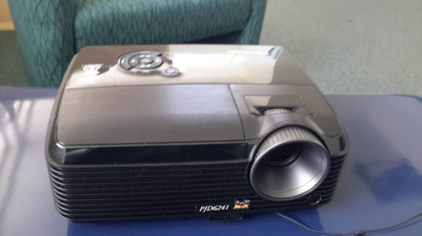

Link to larger image : View Sonic projector

15. 1 x 3 piece suite, green

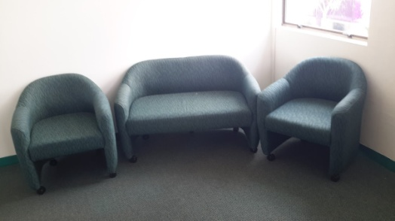

Link to larger image : 3 piece suite, green

16. 1 x blue coffee table (380mm x 1140mm)

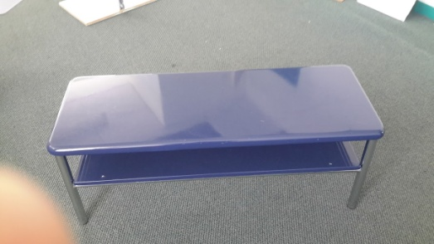

Link to larger image : Blue coffee table

17. 1 x 9 cubbyhole storage unit (390mm x 1200mm, 1200mm high)

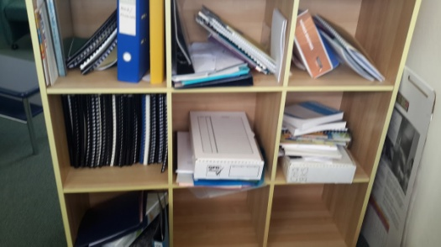

Link to larger image : 9 cubbyhole storage unit

Office 2

18. 1 x HP printer PSC1410 all in one scanner

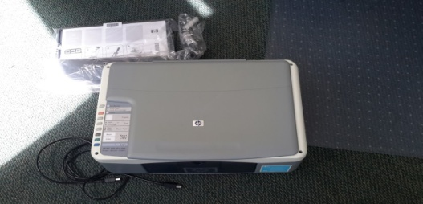

Link to larger image : HP Printer PSC1410 all-in-one scanner

19. 1 x computer desk (1220mm wide x 580mm deep)
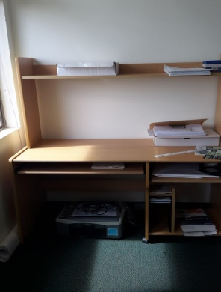

Link to larger image : Computer desk

20. 3 x swivel office chairs

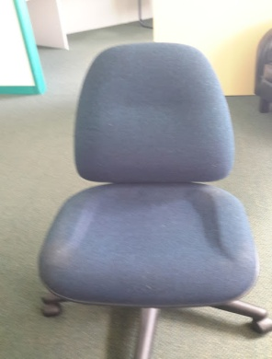

Link to larger image : Swivel office chair

21. 1 x corner office desk

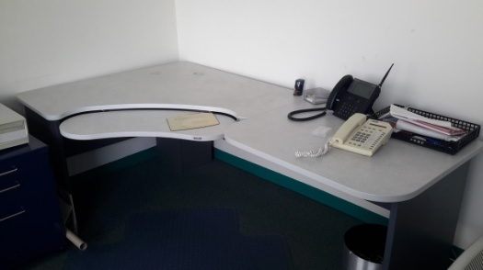

Link to larger image : Corner office desk

Office 3

22. 1 x storage cabinet (890mm x 460mm, 900mm high)

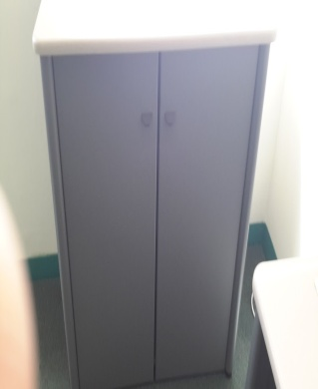

Link to larger image : Storage cabinet

23. 1 x corner desk unit and drawers

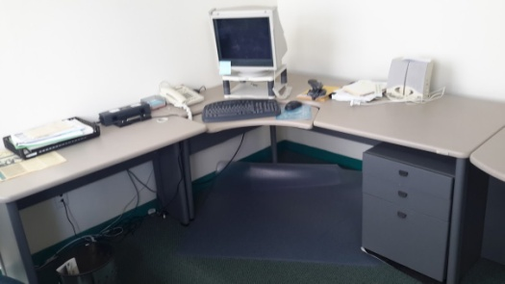

Link to larger image : Corner desk unit and drawers

24. 1 x blue table with 6 steel frame chairs (grey fabric)

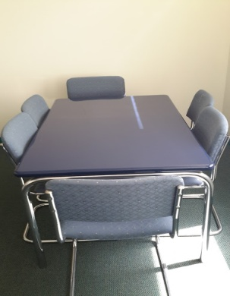

Link to larger image : Blue table with 6 steel frame chairs (grey fabric)

Library

25. 1 x corner office desk

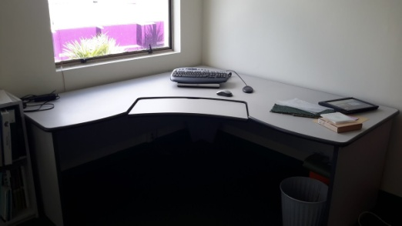

Link to larger image : Corner office desk

26. 2 x 4-cubbyhole units

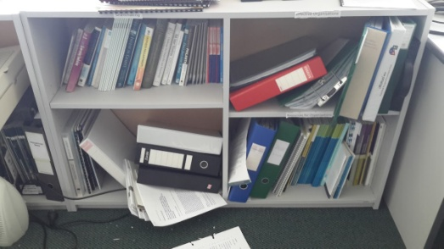
Link to larger image : 4 cubbyhole unit

27. 4 x 2-cubbyhole units

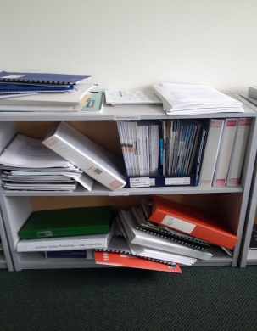

Link to larger image : 2 cubbyhole unit

28. 1 x 4 drawer filing cabinet

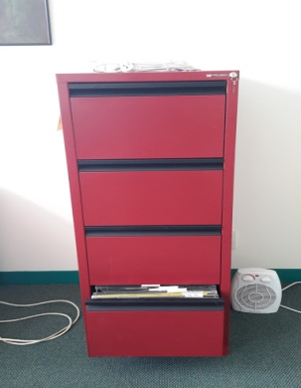

Link to larger image : 4 drawer filing cabinet

29. 1 x hessian noticeboard

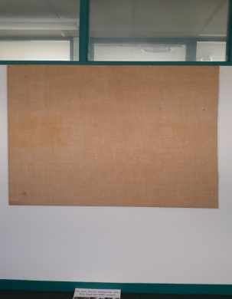

Link to larger image : Hessian noticeboard

Stationery Room

30. 2 x ABC shredder

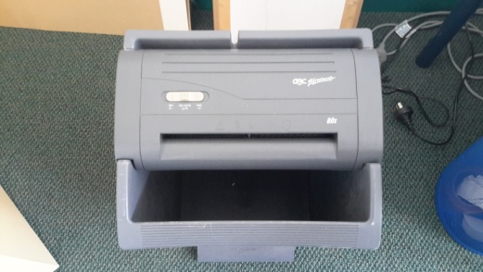

Larger image not available

31. 1 x Canon IR2000 photocopier

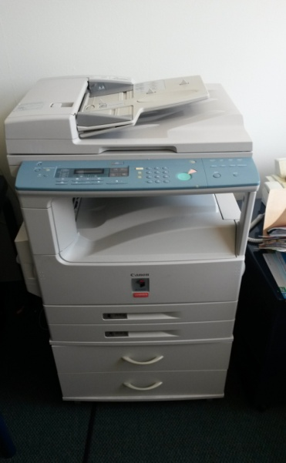

Larger image not available

32. 1 x HP 2100 laser jet printer

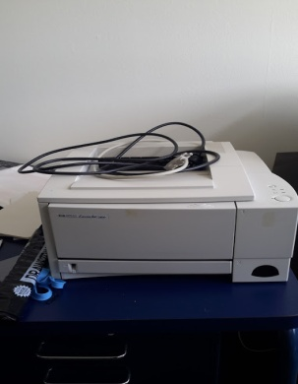

Link to larger image : Canon IR2000 photocopier

33. 1 x office desk (1500mm wide, 720mm deep)

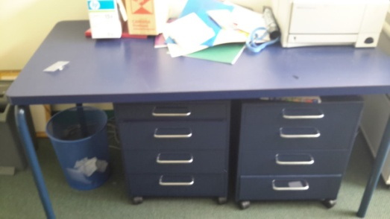

Link to larger image : Office desk

34. 2 x blue storage cupboards (790mm wide, 420mm deep, approx. 1830mm high)

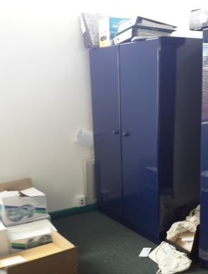

Link to larger image : Blue storage cupboard

35. Office shelving

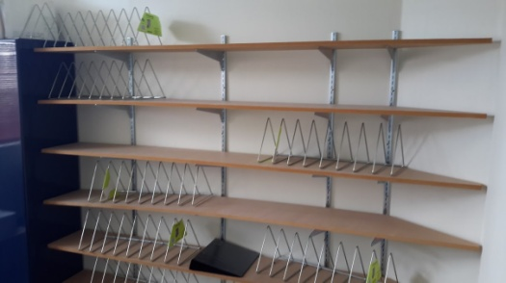

Link to larger image : Office shelving

36. Fax Machine

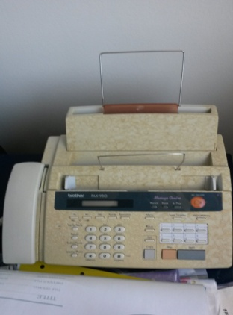

Larger image not available

37. Reception Unit

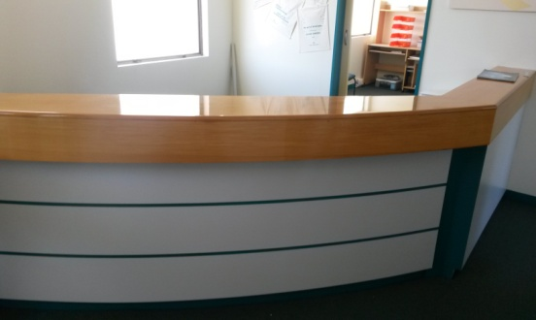

Larger image not available

