Contact Details  Tel: 021 845 977  Hm: 06 7598455 | 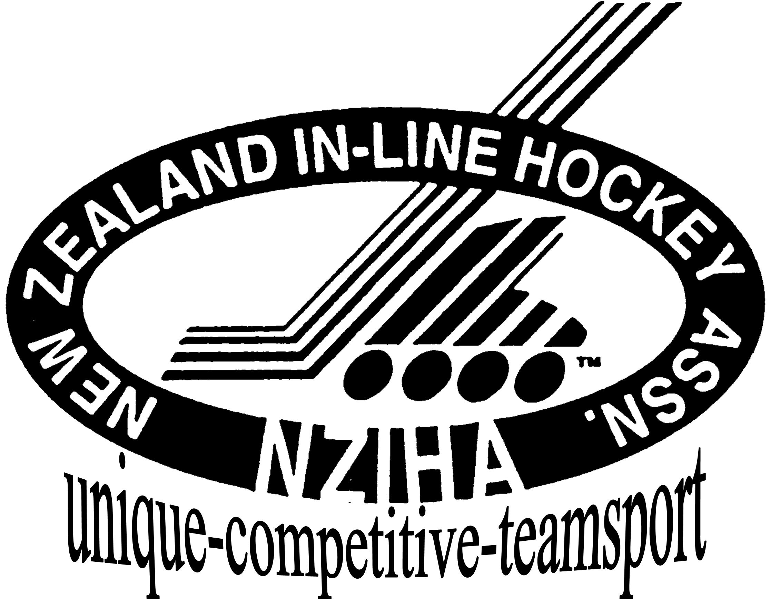  New Zealand Inline Hockey Association  P.O.Box 18001, Merrilands,  New Plymouth, New Zealand  Email: krys.beardman@xtra.co.nz
Dec. 20, 15 | www.inlinehockeynz.org.nz

New Zealand Inline Hockey Team Official’s Application

A limited number of appointments are available for team officials for 2016 New Zealand teams. While all offers are appreciated, the NZIHA advise that only a limited number of appointments are made.

NZIHA have a subsidy policy in place. This can be found on the NZIHA website here.

Officials are appointed on a volunteer basis. Officials are required to cover the cost of NZ Dress Uniform. This consists of a NZ Inline Hockey polo (2) an optional jacket and black shorts or trousers. Shorts or trousers are to be supplied by the appointee.
All applications may be subject to police vetting.

Expressions of interest should indicate experience, age grade preferred and uniform sizing where applicable and be advised to NZIHA, General Manager by January 10th, 2016

The NZIHA must stress that the organisers reserve the right to make appointments at their discretion.
(please circle choices and include grade)

Preferred Event: AAU (Hawaii) or WORLD CHAMPS

Preferred Grade: Application for: Manager - Team Official - Driver (AAU only)

Name: Phone: Mob:

Address:

Email: Drivers License:

Polo Size: Jacket Size: (optional)

Reference can be requested from: Name: Phone/Mobile:

Your Signature: Dated:

Experience: Please attach a brief summary of your experience related to the position being applied for.

If successful in being appointed you will be required to sign an “Official’s Agreement” prior to participation.
Please email this form back to krys.beardman@xtra.co.nz
If you have any questions, please do not hesitate to email.
Kind regards
Krystyna Beardman
General Manager - Operations
New Zealand Inline Hockey Association

